Simulating an isolated microgrid powered economy

Creating a peer-to-peer economy by agent based modelling

By Spurrya Jaggi

“We're leading a fundamental shift from centralized energy to distributed energy. Energy will go in that direction, just like mainframe computers went to client servers, then to the Internet.” – Lynn Jurich

## Table of Contents

Table of Contents 3

1. Problem 4

2. Microgrids as a solution 5

3. Simulation 6

Purpose of report 6

Input Parameters: 6

Randomness in the model: 7

Probability in the model: 7

Simulation Parameters: 8

Behaviour of each agent: 9

Incentive Based Programs: 9

4. Results 10

Understanding the simulation 10

5. Limitations and Recommendations: 11

6. Next Steps 13

7. Conclusion 14

# Problem

The global energy crisis has severe implications on densely populated nations such as India. 3 billion people globally still rely on kerosene and solid fuels for cooking and heating, and over 1 billion lack access to electricity. [https://mashable.com/2017/09/17/how-rockefeller-foundation-is-bringing-electricity-to-villages-in-india/#y6I3j3Lm5sq8]. People living here lack access to clean, affordable, and reliable energy. Since many of these communities are not recognized by the Indian government, they do not receive any support or services and are left to fend for themselves.

Households lacking access to electricity are forced to rely on biomass or kerosene for cooking and lighting. Their toxic combustion puts families, especially women and children, at a much higher risk of deadly respiratory diseases, leading to 4.3 million premature deaths every year. [http://www.who.int/mediacentre/factsheets/fs292/en/]

The inability to regularly use electrical appliances prevents member of these communities from adopting a modern lifestyle, thus putting them at an economic disadvantage. Time and money spent on biomass and kerosene also deprives people of educational and employment opportunities. In off-grid communities where the average income is 100 Rupees a day, a liter of kerosene costs 75 Rupees.[solar dc microgrid for rural electrification - a case study] This is a significant financial burden to those who do not have electricity access. All of this limits their upward mobility and puts them in a perpetual debt cycle.

# Microgrid as a solution

Grid extension is often very costly and not feasible in isolated off grid communities. In such situations, electricity mini-grids or microgrids can power household use and local businesses.  Challenge of today is not only to produce electricity without upsetting nature but to efficiently transmit and utilize the same. Despite massive rural electrification plans, India has nearly 54000 unelectrified off grid communities.  In most of the electrified off-grid communities not only the connected households are a fraction of the total but power is available on an average of 4 hours per day. [cite paper]

Micro grids have gained research interest during the last years.  A DC micro grid(capacity < 1.5 kW) is a part of power systems which autonomously operate in island mode when the loads are supplied from locally distributed resources.  A low-voltage dc micro grid is used

to supply sensitive electronic loads, since it combines the advantages of using a dc supply for electronic loads, and using local generation to supply sensitive loads. Micro grid concept widely implemented in rural areas of India. The increase in researches due to benefits of this type of networks including provide the reliability and security of network and loads, high efficiency, environmentally friendly and self-healing.  In today‘s power systems, very

large problems including electricity production cost and also reduce of fossil fuel, on the other hand, the increasing pollution created from burning oil and gas and dramatically growth of demands has been increase the greenhouse gases in the air which is considered as a big

threat for ozone layer. [SOLAR DC MICROGRID FOR RURAL ELECTRIFICATION]

# Simulation

An agent based model was created to simulate how the economy of an isolated un-electrified community will be developing by creating a micro-grid.

Purpose of report**:** It is to find how micro-grids behave, their development and, how the behavior and saving of the producers and consumers change based on the cost at which producers sell their electricity to the consumers.

## Input Parameters**:**

The following table shows parameters used in developing the simulation based of a case study conducted in a rural village of India described in the paper “Solar DC Microgrid for rural electrification - a case study”[].  The price of the solar panel and estimated output was estimated by consulting a business in India, Pico Energy.

|  |  |
| --- | --- |
| Parameters | Units |
| Hourly electricity needs per villager | 6 W-hr |
| Hours of electricity required | 5 hours |
| Daily electricity needs per villager | 30 W-hr/daily |
| Daily Income | 100 Rupees |
| Cost of 1 W-hr of electricity by producer | 5 Rupees |
| Cost of alternative fuels such as Kerosene | 75 Rupees |
| Cost of 1 unit of solar panel and battery storage sold by Pico Energy | 1500 Rupees |
| Output of 1 unit of solar panel | 60 W- hr |

Based on the above parameters, the parameters for the simulations were taken. They were scaled down by a factor of 10.

Following are additional parameters in the model for a more realistic model:

## Randomness in the model:

Many of them allowed the simulation to have variance in the data as all the above statistics are the average. Different agents have different income, different energy requirements, different expenditures and lastly, since the micro-grid is being developed on solar energy, the energy produced daily will not be the same. Hence, a small variance is all the parameters above.

## Probability in the model:

Incentiving an agent to be a producer by increasing the returns on 1 unit of electricity (= 1 W-hr). They are more likely to want to be a producer as there is a significant upfront cost on the solar panel.

The probability of buying kerosene if their daily needs are not satisfied is lowered to allow the agent from saving in order to potentially buy a solar panel. If the probability of buying kerosene to fulfill daily energy requirements is not lowered, the agent will be in a perpetual downward cycle.

The agents are more incentivized to produce more electricity if their own electricity needs or their neighbors are not being met. The producer has an option to buy more solar panels or the neighbors can choose the become a producer.

## Simulation Parameters:

Based on the above background research, the following parameters were picked while simulating.

  "width":10,

  "height":10,

  "consumption_of_energy_mean": 3,

  "consumption_of_energy_std":0.1,

  "daily_production_of_energy_mean": 6,

  "daily_production_of_energy_std": 1,

  "daily_outcome_mean": 2,

  "daily_outcome_std":0.1,

  "daily_income_mean":10,

  "daily_income_std":0.5,

  "price_of_alternative_fuels":7.5,

  "price_of_solar_panel":150,

  "price_of_electricity_from_producer": 0.5,

  "probability_of_converting_into_producer":0.15,

  "probability_of_neighbour_converting_into_producer":0.05

Since the probability of converting into a producer depends on the amount of money the producer receives, it is taken into account as following:

parameters["probability_of_converting_into_producer"] = parameters["probability_of_converting_into_producer"] * parameters["price_of_electricity_from_producer"]/ 100

parameters["probability_of_neighbour_converting_into_producer"] = parameters["probability_of_neighbour_converting_into_producer"] * parameters["price_of_electricity_from_producer"] / 100

## Behavior of each agent:

1. All the agents are provided an income based on the parameter: “daily_income_mean” and to for deviation in the model the parameter: “daily_income_std” is used.
2. After the income, the net savings for the day is calculated after taking out other expenses (does not include electricity cost).
3. All the producers presented on the grid produce electricity based on the day. A day can be cloudy which will reduce the electricity produced or sunny which will increase it.
4. The producer then consumes the energy for himself before selling to his neighbour.
5. The producer trade electricity with all the neighbour till there is no more electricity needs or the neighbour does not have enough money to buy more.
6. If an agent’s daily energy needs were not met and they have enough money for today and savings, the agent can purchase kerosene. However, since the cost of kerosene is high and the agents are incentivized to save in the simulation, the agent may not be able to get all their energy needs fulfilled for the day.
7. The savings of all the agents is updated based on the day’s savings
8. All agents are given a chance to convert into producer given they have enough savings to afford a solar panel and enough incentives, they will convert into a producer making all their neighbours consumers.

## Incentive Based Programs:

Incentive-based programs try to incentive a neighbour to come a producer to contribute towards the microgrid. This can usually be in form of a payment or reward. For the purpose of this project, the price of alternative fuels such as Kerosene was high while the cost of consuming from a producer was low.

**Incentives Provided:** If an agent owns enough money to buy a PV solar cell and, there is at least one neighbor who does not have their daily energy needs, they are incentives to become a producer. However, if everyone's energy needs in the surrounding were satisfied, the probability of everyone wanting to converting to producer decreases.

# Results

## Understanding the simulation

|  |  |
| --- | --- |
|  | A producer who owns 1 solar panel |
|  | A consumer |
|  | An alternative fuels user such as Kerosene |
|  | Agents whose energy needs for the day have been fulfilled. |
|  | The size of the agent represent agent’s savings |

In the beginning, all the agents are randomly generated each with the parameters specified above as shown below in Figure XX

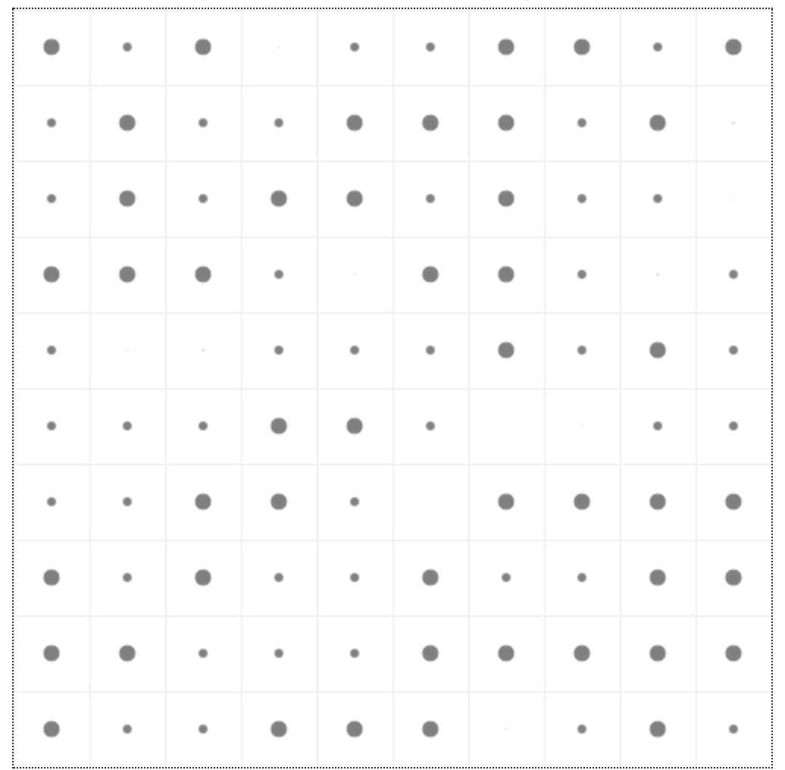

Figure XX: Random initiation of agents with different savings

Some of the agents used their savings for a temporary solution and decided to buy kerosene as shown below in Figure xx.

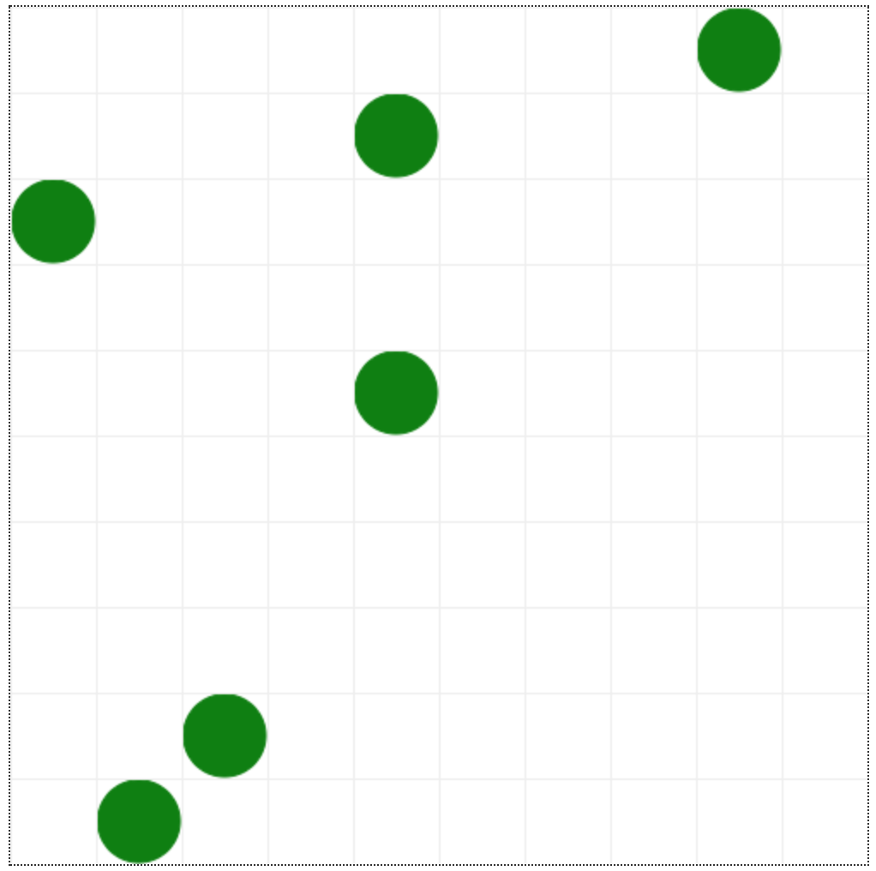

Figure XX: Some agents brought kerosene and satisfied their energy requirements for the day

When the production of electricity is low, all the neighbours of the producer are not guaranteed all units of electricity as shown in the next sequence of iterations. Furthermore,

The following are the next few steps of the simulation when price of electricity to consume is **0.5 units** or 5 rupees:

|  |  |  |
| --- | --- | --- |
|  |  | |
|  | |  |
|  | |  |
|  | |  |
|  | |  |
|  | |  |
|  | |  |

80% of the population has access to their daily needs of electricity **within 14 iterations of the simulation.**

To see how quickly the microgrid grows and how the savings of the agents change.

The value of price at which electricity is sold is change from 0.5 units (5 rupees) to 2 units (20 rupees):

|  |  |
| --- | --- |
|  |  |
|  |  |
|  |  |
|  |  |
|  |  |

80% of the population has access to their daily needs of electricity within **10 iterations of the simulation** with a standard deviation of 42 money units or 420 Rupees

## Observations

# Limitations and Recommendations:

This simulation has several limitations as it does not represent a real-world. It follows rules of what would be a good choice to make but that necessarily is not how the real-world behaves. There are few areas of improvements identified such as:

Producer’s neighbor converting into a producer: To improve the model, the simulation can take into account the probability of an agent converting into a producer given the fact their neighbor already produces electricity for them. The probability of a producer upgrading solar cells to serve his neighbors is more due to the gained experience and responsibility.

Simulation does not take debt into account: In the simulation, the agents are provided income daily with a little saving. However, in real-world scenarios, people have debt with interest, which often induces perpetual down cycle.

Micro-grids success depends on community engagement**:** One of the failure points for micro-grid is lack of community engagement. Since micro-grids are designed for a community, it is necessary to involve the stakeholders of the community to achieve sustainable energy planning and development.

Lack of revenue generation**:** A good micro-grid system is self-sustaining in terms of income and revenue generation, arising from the energy trades by the intended users in the community.

High initial cost of installation**:** A micro-grid consists of the PV solar cells that can be expensive as opposed to a “quick fix” that alternative fuels such as Kerosene offer. There needs to be an incentive for a Kerosene user to convert into a producer and save for the long term. Saving behavior is not easy to quantify and model.

Energy production is uncertain**:** Since a lot of micro-grid system rely on solar energy, the production of electricity is not certain. There can be times when there is more electricity produced than required and times when basic energy needs cannot be fulfilled.

Block-chain to verify transactions: The use of blockchain during the implementation of microgrid solution will be beneficial to provide transparency and increase accountability. It will promote the growth of microgrids as the producers can expect the neighbours who used their electricity to pay them for it.

# Next Steps

This model was created to aid the author, one of the co-founders of a peer to peer energy transaction company, Prava by seeing the behaviours of how agents will expect to behave.

# Conclusion

Places microgrids fail:

[www.mdpi.com/1996-1073/11/2/432/pdf](http://www.mdpi.com/1996-1073/11/2/432/pdf)

Microgrid Expansion

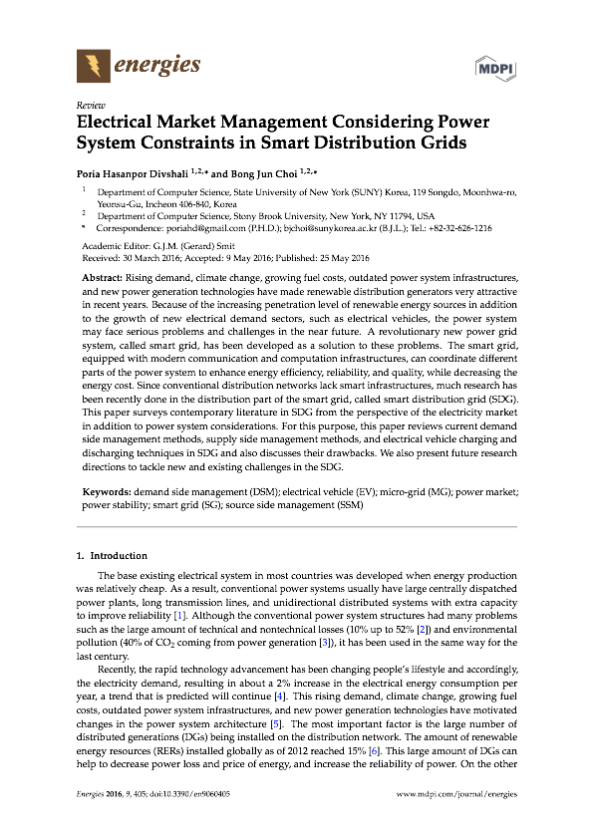

A producer will want an income for the energy they produce to help offset the high cost of buying a solar panel, whereas a consumer will look for sustainable, economical and reliable source of electricity. Both consumer and producers are stakeholders who have to be incentivized to participate in energy trade for

**Price of electricity 8:**

->Pricing it higher than kerosene -> no effect

->Pricing it lower means consumers are interested in buying the electricity than investing long term -> long term profit/ benefit for the producer -> producer is incentivized to buy additional solar panels

-> Pricing it higher means consumers are interested in their own solar panel and it means most of the community becomes it own consumer